**public class Aplikasi extends javax.swing.JFrame {**

**/\*\***

**\* Creates new form Aplikasi**

**\*/**

**public Aplikasi() {**

**initComponents();**

**}**

**/\*\***

**\* This method is called from within the constructor to initialize the form.**

**\* WARNING: Do NOT modify this code. The content of this method is always**

**\* regenerated by the Form Editor.**

**\*/**

**@SuppressWarnings("unchecked")**

**// <editor-fold defaultstate="collapsed" desc="Generated Code">**

**private void initComponents() {**

**jcelcius = new javax.swing.JLabel();**

**fahrenheitLabel = new javax.swing.JLabel();**

**reamurLabel = new javax.swing.JLabel();**

**celciusTextField = new javax.swing.JTextField();**

**convertButton = new javax.swing.JButton();**

**setDefaultCloseOperation(javax.swing.WindowConstants.EXIT_ON_CLOSE);**

**jcelcius.setText("Celcius");**

**fahrenheitLabel.setText("Fahrenheit");**

**reamurLabel.setText("Reamur");**

**convertButton.setText("convert");**

**convertButton.addActionListener(new java.awt.event.ActionListener() {**

**public void actionPerformed(java.awt.event.ActionEvent evt) {**

**convertButtonActionPerformed(evt);**

**}**

**});**

**javax.swing.GroupLayout layout = new javax.swing.GroupLayout(getContentPane());**

**getContentPane().setLayout(layout);**

**layout.setHorizontalGroup(**

**layout.createParallelGroup(javax.swing.GroupLayout.Alignment.LEADING)**

**.addGroup(layout.createSequentialGroup()**

**.addGap(62, 62, 62)**

**.addGroup(layout.createParallelGroup(javax.swing.GroupLayout.Alignment.LEADING, false)**

**.addComponent(convertButton, javax.swing.GroupLayout.DEFAULT_SIZE, javax.swing.GroupLayout.DEFAULT_SIZE, Short.MAX_VALUE)**

**.addComponent(celciusTextField))**

**.addGap(45, 45, 45)**

**.addGroup(layout.createParallelGroup(javax.swing.GroupLayout.Alignment.LEADING)**

**.addComponent(jcelcius)**

**.addComponent(fahrenheitLabel)**

**.addComponent(reamurLabel))**

**.addContainerGap(82, Short.MAX_VALUE))**

**);**

**layout.setVerticalGroup(**

**layout.createParallelGroup(javax.swing.GroupLayout.Alignment.LEADING)**

**.addGroup(layout.createSequentialGroup()**

**.addGap(54, 54, 54)**

**.addGroup(layout.createParallelGroup(javax.swing.GroupLayout.Alignment.BASELINE)**

**.addComponent(jcelcius)**

**.addComponent(celciusTextField, javax.swing.GroupLayout.PREFERRED_SIZE, javax.swing.GroupLayout.DEFAULT_SIZE, javax.swing.GroupLayout.PREFERRED_SIZE))**

**.addGroup(layout.createParallelGroup(javax.swing.GroupLayout.Alignment.LEADING)**

**.addGroup(layout.createSequentialGroup()**

**.addPreferredGap(javax.swing.LayoutStyle.ComponentPlacement.UNRELATED)**

**.addComponent(fahrenheitLabel)**

**.addGap(18, 18, 18)**

**.addComponent(reamurLabel))**

**.addGroup(layout.createSequentialGroup()**

**.addGap(24, 24, 24)**

**.addComponent(convertButton)))**

**.addContainerGap(87, Short.MAX_VALUE))**

**);**

**pack();**

**}// </editor-fold>**

**private void convertButtonActionPerformed(java.awt.event.ActionEvent evt) {**

**double celcius = Double.parseDouble(celciusTextField.getText());**

**double fahrenheit = celcius * 1.8 + 32;**

**double reamur = celcius * 0.8;**

**fahrenheitLabel.setText(fahrenheit + " Fahrenheit");**

**reamurLabel.setText (reamur + " Reamur");// TODO add your handling code here:**

**}**

**/\*\***

**\* @param args the command line arguments**

**\*/**

**public static void main(String args[]) {**

**/* Set the Nimbus look and feel */**

**//<editor-fold defaultstate="collapsed" desc=" Look and feel setting code (optional) ">**

**/* If Nimbus (introduced in Java SE 6) is not available, stay with the default look and feel.**

**\* For details see http://download.oracle.com/javase/tutorial/uiswing/lookandfeel/plaf.html**

**\*/**

**try {**

**for (javax.swing.UIManager.LookAndFeelInfo info : javax.swing.UIManager.getInstalledLookAndFeels()) {**

**if ("Nimbus".equals(info.getName())) {**

**javax.swing.UIManager.setLookAndFeel(info.getClassName());**

**break;**

**}**

**}**

**} catch (ClassNotFoundException ex) {**

**java.util.logging.Logger.getLogger(Aplikasi.class.getName()).log(java.util.logging.Level.SEVERE, null, ex);**

**} catch (InstantiationException ex) {**

**java.util.logging.Logger.getLogger(Aplikasi.class.getName()).log(java.util.logging.Level.SEVERE, null, ex);**

**} catch (IllegalAccessException ex) {**

**java.util.logging.Logger.getLogger(Aplikasi.class.getName()).log(java.util.logging.Level.SEVERE, null, ex);**

**} catch (javax.swing.UnsupportedLookAndFeelException ex) {**

**java.util.logging.Logger.getLogger(Aplikasi.class.getName()).log(java.util.logging.Level.SEVERE, null, ex);**

**}**

**//</editor-fold>**

**/* Create and display the form */**

**java.awt.EventQueue.invokeLater(new Runnable() {**

**public void run() {**

**new Aplikasi().setVisible(true);**

**}**

**});**

**}**

**// Variables declaration - do not modify**

**private javax.swing.JTextField celciusTextField;**

**private javax.swing.JButton convertButton;**

**private javax.swing.JLabel fahrenheitLabel;**

**private javax.swing.JLabel jcelcius;**

**private javax.swing.JLabel reamurLabel;**

**// End of variables declaration**

**}**

**CODING**

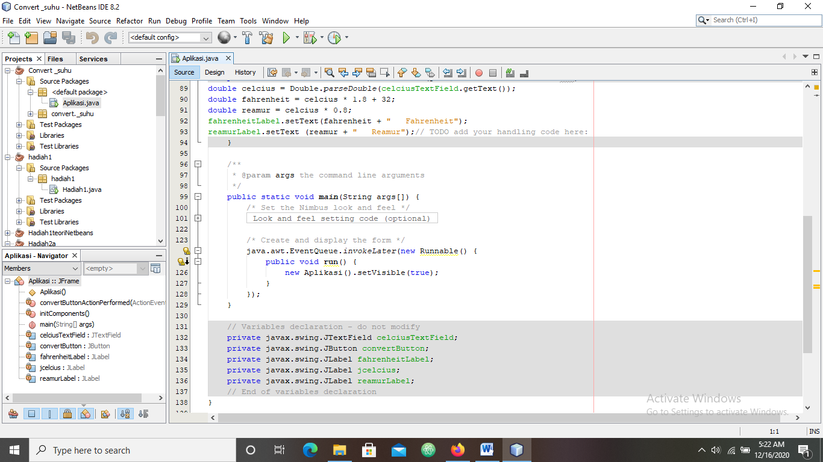

**DESAIN**

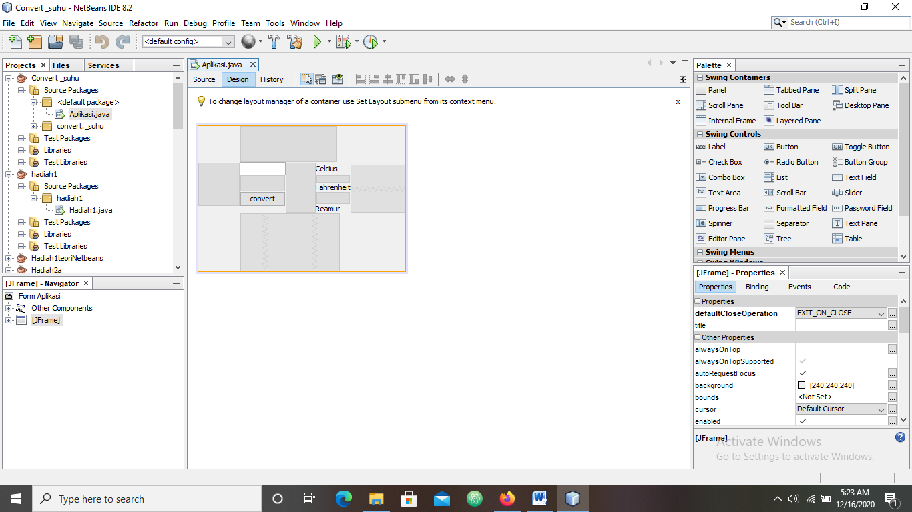

**HASIL RUN**

